Field Work Automation

Table of Contents

About Mobile Field Work Automation 4

Lexicon Mobile Field Work Force High-level Architecture 5

Typical Architecture of Worklight Adaptor and Cast Iron Integration based solution 5

Lexicon’s Core application 6

1. Web Application 6

2. Mobile Application 6

3. Server Back-end Application 6

Cast-iron Integration Service 6

End points (Applications) 7

Lexicon Mobile Field Work Force: Modules Overview 8

Web Application 8

1. Manager Dash Board 8

Internal Personnel Message 9

Application Activity Message Ticker 9

Geo Position of personnel 9

Schedule Viewer 10

Performance Analysis Pie Charts 10

2. Customer Mgmt 10

- Add new 10

- Search and Edit customer 11

3. Service Request Mgmt 12

- Add new 12

- Search and Edit service request 13

4. Work Order Mgmt 14

- Add New 14

- Search 15

- Task Creation 16

5. Internal Messages 18

- Create and Send Messages 18

Mobile Application 18

1. Work Order Task Mgmt 18

- Accept / Reject Task 18

- Task Status 18

- Capture Image and Attach to task 19

- Notes 19

- Related Customer details and History 19

- Task related Inventory 19

- Estimation & Invoicing 19

2. Inventory Mgmt 19

- Service Engineer's allocated Inventory stock 19

- Requisition for additional Inventory 20

3. Message Module 20

- Create Message 20

# About Mobile Field Work Automation

The Mobile Field Work App (MFWA) is a game changer for organizations looking for a real-time solution to manage their field service personnel. MFWA is the first natively mobile field service application that is fully integrated to backend system or record. MFWA will maximize productivity by allowing field service personnel to have all the information they need in the palm of their hands to execute an assignment. The MFWA application provides them with instant access to work order details, job history, con-tact and location information, asset information, customer service information and notifications all in one interface.

The fast, easy & reliable MFWA can be deployed across multiple platforms to meet the needs of organizations with a BYOD culture. MFWA's flexible functionality and deployment model translates to success for companies in a wide variety of industries. No matter your mobile work force specialty, MFWA has helped transform businesses like yours by improving service to the end customer and increasing the bottom line with higher productivity of the field service staff. The other transformation that can occur is to view the field staff as a source of revenue to further up sell additional services and minimize subscriber churn.

**With MFWA**

* Increase productivity
* Increase service revenue
* Reduce costs associated with field services
* Increase first time fix rates
* Decrease average-time-to-repair

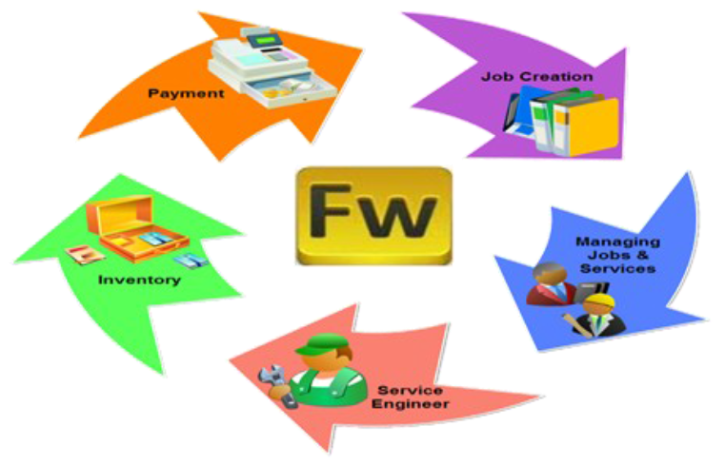

# Lexicon Mobile Field Work Force High-level Architecture

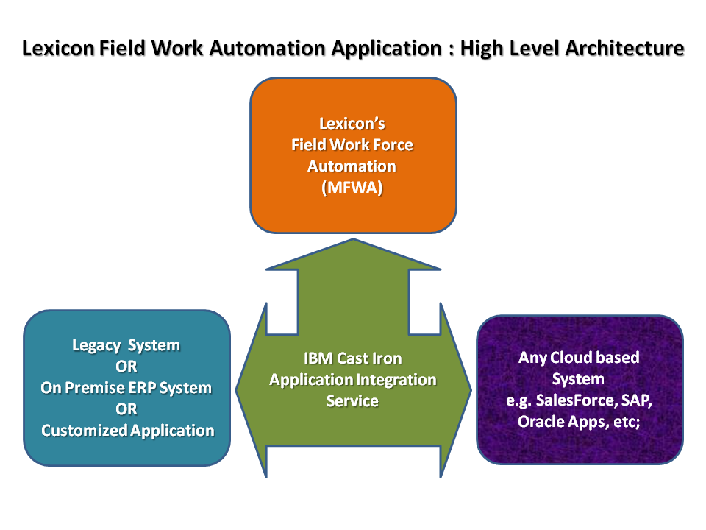

Fig: Lexicon Field Work Force Automation System’s High level architecture

As shown in the above figures there are total three main components Lexicon’s Core application, Integration Service Bus Module and End points such as customer’s existing system, customer’s any operational cloud application, customer’s MES system, etc;. These components are described as follows:

## Typical Architecture of Worklight Adaptor and Cast Iron Integration based solution

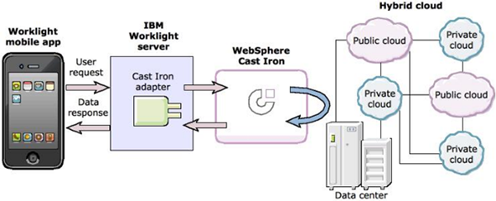

Fig: Typical Architecture for Mobile Field Work Automation solution

## Lexicon’s Core application

Core application is designed in the IBM WorkLight Framework 5.0. This complete application consists of three main components as

### Web Application

This is the main Administrative application. In this application there are administrative as well as operational module such as Master Creation & Management, and Operational activities such as Service Request, Work Order, Task, Inventory; etc

### Mobile Application

This is the Field Personnel (Service Engineer) application. Activities available in this application are the sub-set of core main application (Web Application). Here only Task related activates can be done e.g. Task Accept/Reject, Task-Status change, Task related Inventory requisition and consumption, etc;

### Server Back-end Application

This is the Server side back-end application. This deals with Business Process Libraries, Data Access Layer, Messaging, Notifications, etc;

## Cast-iron Integration Service

This is the IBM Cast Iron Integration Service Tool, which is used to integrate two different applications for data synchronization. The Integration Touch points can be web services, Databases, or application API. This tool not only connects two end-points and synchronizes data, but it also capable of data processing (Massaging) during the data synchronization. Hence it provides a kind of adaptor (which can accept one type as **I**nput and produces another type as **O**utput) and works as a bridge between two standalone systems / applications.

The Cast Iron can integrate multiple endpoints (more than two) any given point of time. Cast Iron is such a smart enough to add / remove end points. Means the scalability and flexibility of Cast Iron gives more strength to the integration modules.

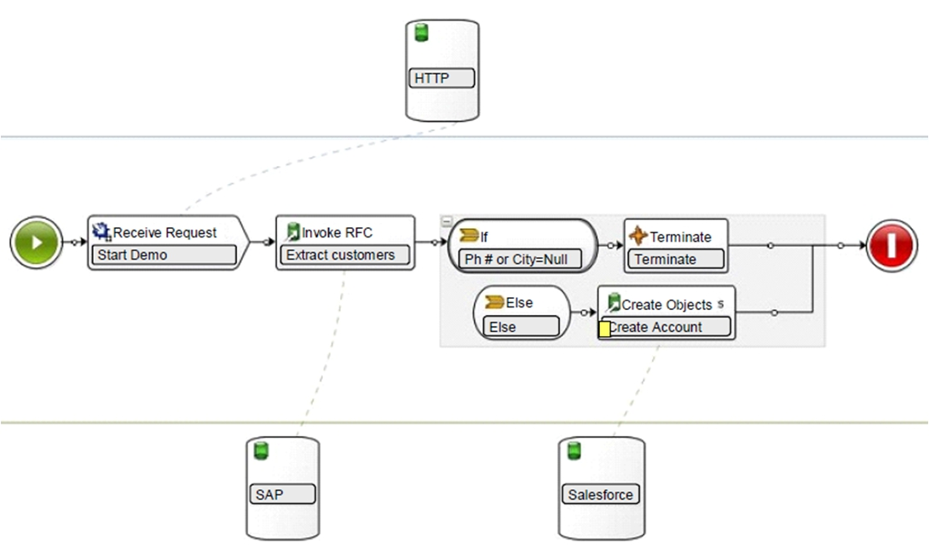

Fig: Typical Cast Iron Orchestration (Data Synchronization) Routong.

## End points (Applications)

This End point (end application) can be anything of kind such as legacy system, on premise ERP, hosted ERP, tailor-made customized application, cloud application, MIS or MES.

The integration bus integrates two different applications. The end points may be same or combination of any end points. In case of MFWA system, we have used Lexicon Core application, Tailor-made customized web based application as customer’s existing application and SalesForce.com as customer’s cloud application.

# Lexicon Mobile Field Work Force: Modules Overview

The Mobile Field Work Force application is consists of two different applications with different platforms.

Functionality and Process flow of each application is described as follows.

# Web Application

This application is designed on top up of IBM Worklight architecture framework.

Log-in Screen:

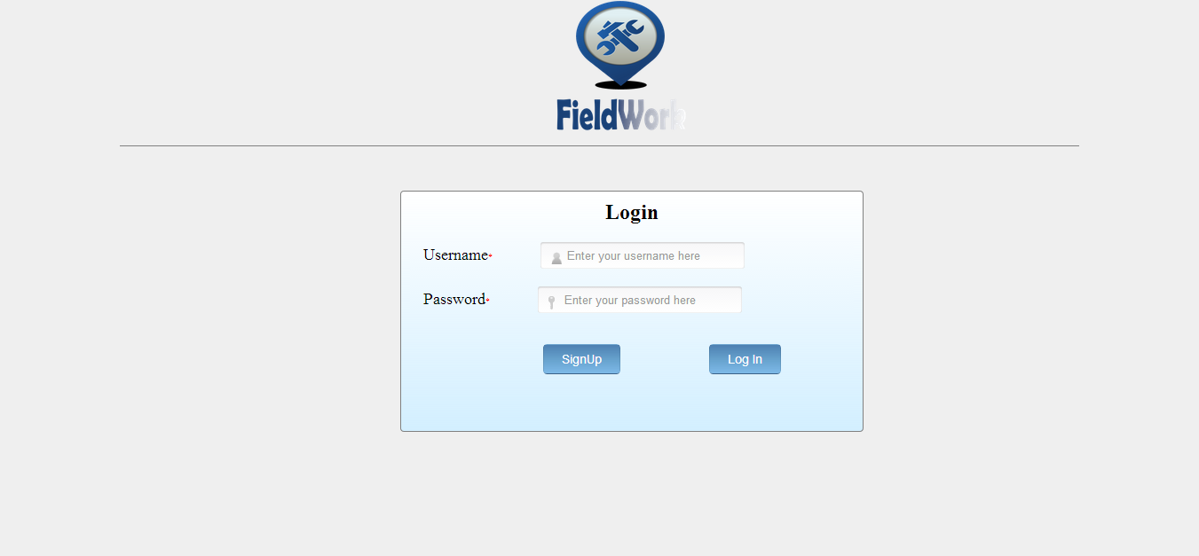

## Manager Dash Board

Description:

**A dashboard provides** at-a-glance views of KPIs (key performance indicators) relevant to a particular objective or business process (e.g. sales, marketing, human resources, or production). Dashboards give signs about a business letting the user know something is wrong or something is right. The corporate world has tried for years to come up with a solution that would tell them if their business needed maintenance or if the temperature of their business was running above normal. A dashboard is limited to show summaries, key trends, comparisons, and exceptions. There are four Key elements considered while designing this dashboard, they are as follows:

1. Simple, communicates easily
2. Minimum distractions...it could cause confusion
3. Supports organized business with meaning and useful data
4. Applies human visual perception to visual presentation of information

Screen shot:

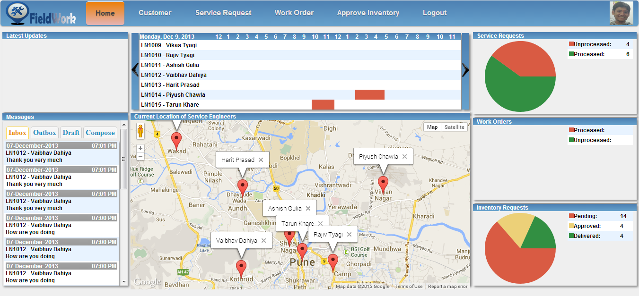

### Internal Personnel Message

Process Description:

The internal message system differs from an e-mail account in several ways. You cannot send or receive messages from other message systems or from e-mail. This means that you can only send and receive messages from other its dashboard users. The internal message system can be used to send messages to groups, or a group of course or project participants, or simply to send messages to teachers or friends without having to leave its dashboard.

One of the advantages is that the user receives new messages once they log in to its dashboard. If you are logged in to its dashboard, you are notified when new internal messages arrive in the list of Messages in its Inbox.

Screen shot:

### Application Activity Message Ticker

Process Description:

This application uses internal application activity tickers to intimate users (Managers) about the activities being done in the team. It is displayed in customized desktop list that are updated whenever a work-order’s Task execution related activity happens. Application uses a scrolling desktop ticker to keep staff informed of the latest updates and news without disrupting their work.

Screen shot:

### Geo Position of personnel

Process Description:

Screen shot:

### Schedule Viewer

Process Description:

Screen shot:

### Performance Analysis Pie Charts

Process Description:

#### = Service Request

Process Description:

Screen shot:

#### = Work Order

Process Description:

Screen shot:

#### = Inventory Request

Process Description:

Screen shot:

## Customer Mgmt

Description:

### - Add new

Process Description:

Screen shot:

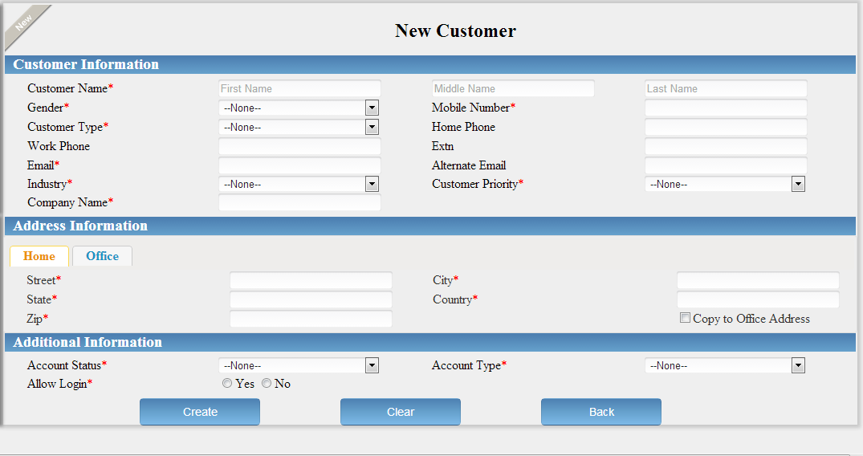

### - Search and Edit customer

Process Description:

Screen shot:

1. Customer Search

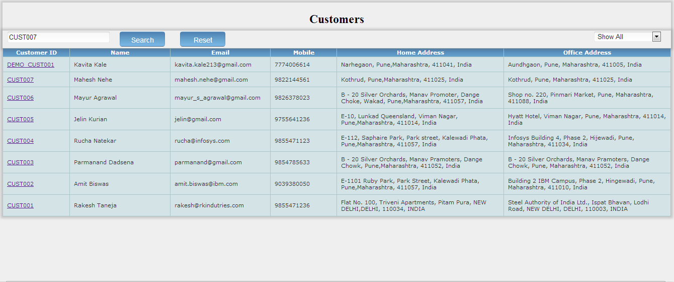

1. Customer Edit

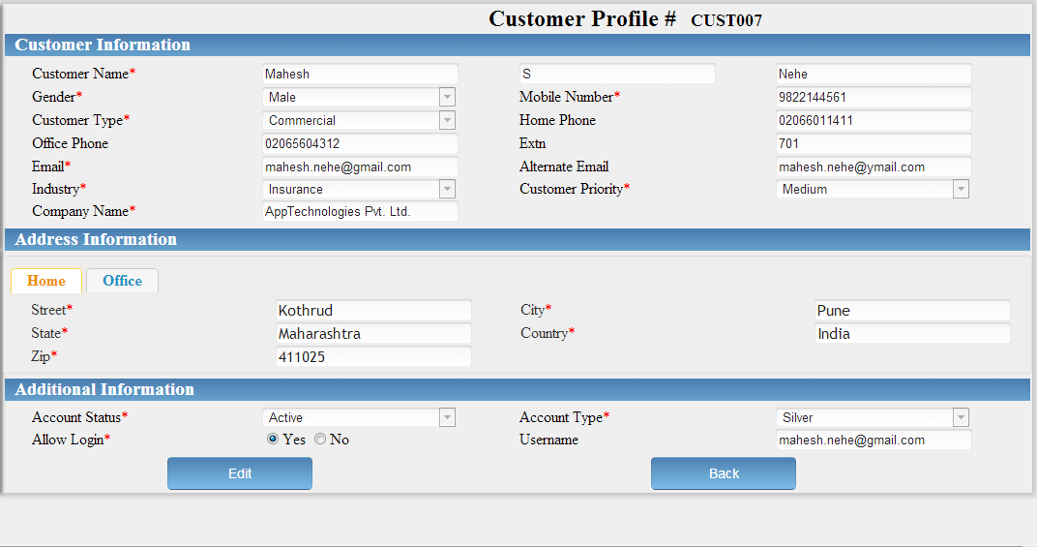

## Service Request Mgmt

Description:

### - Add new

Process Description:

Screen shot:

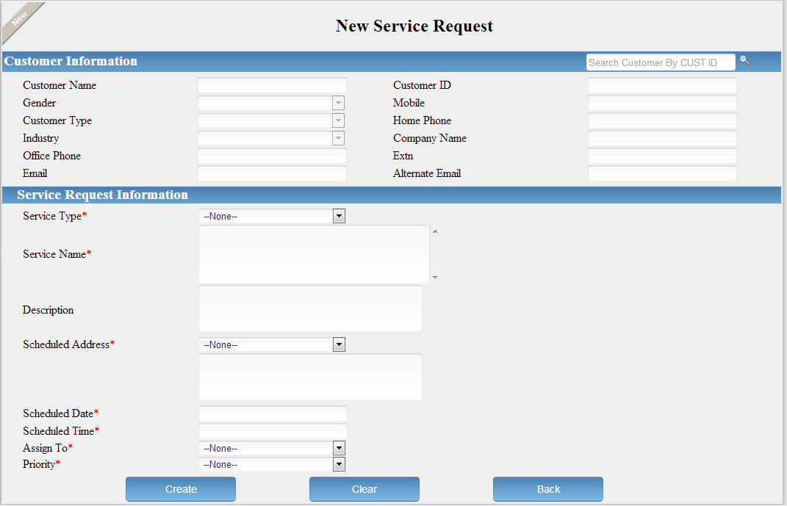

### - Search and Edit service request

Process Description:

Screen shot:

1. Service Request Search

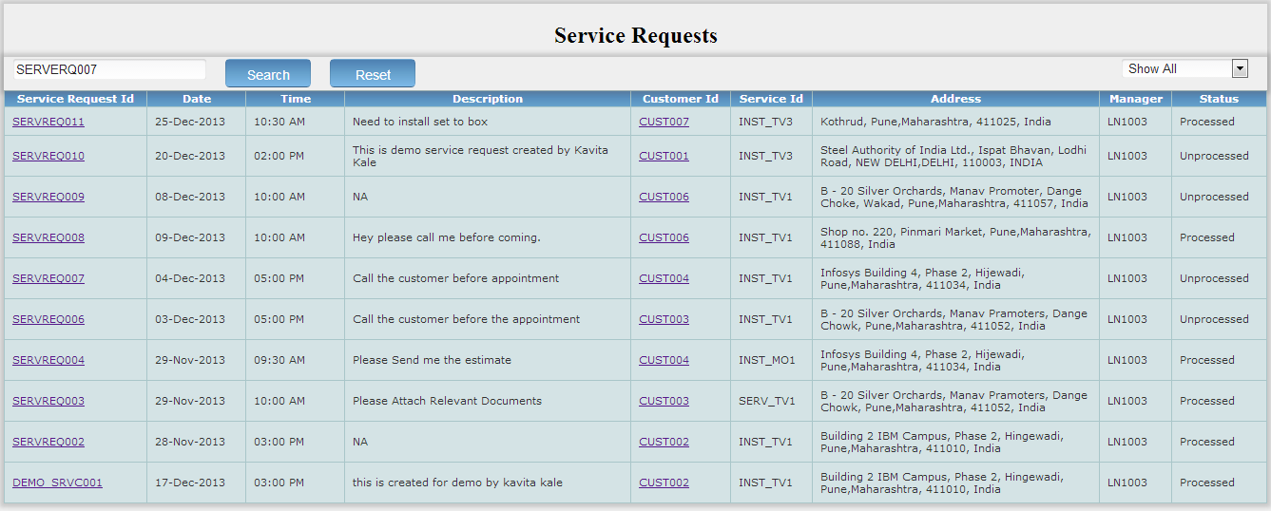

1. Service Request Edit

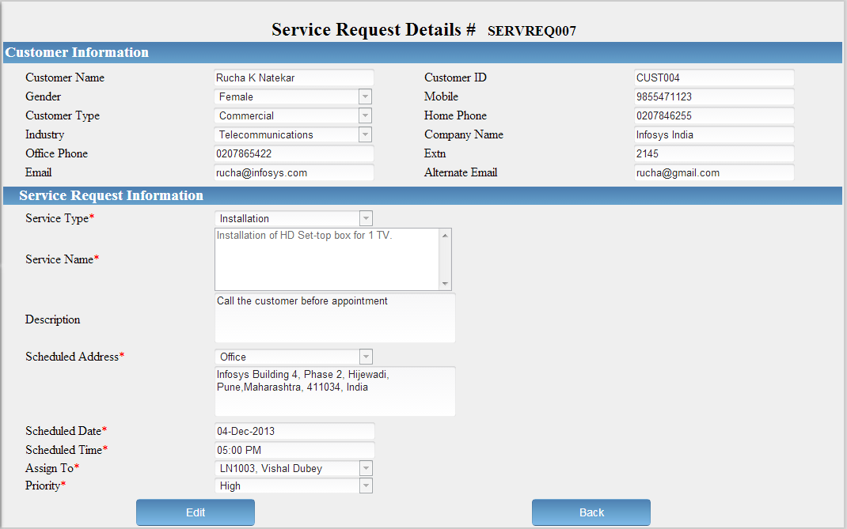

## Work Order Mgmt

Description:

### - Add New

Process Description:

Screen shot:

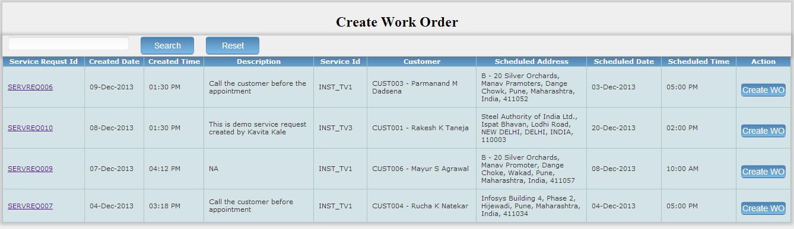

### - Search

Process Description:

Screen shot:

1. Work-Order Search

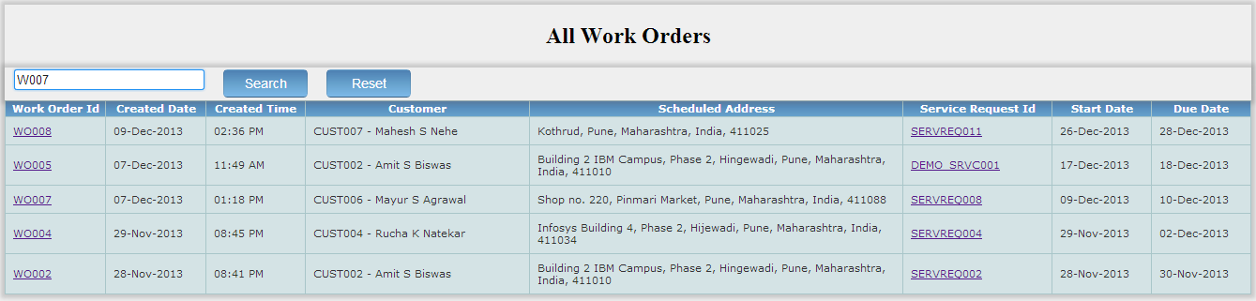

1. Work-Order Edit

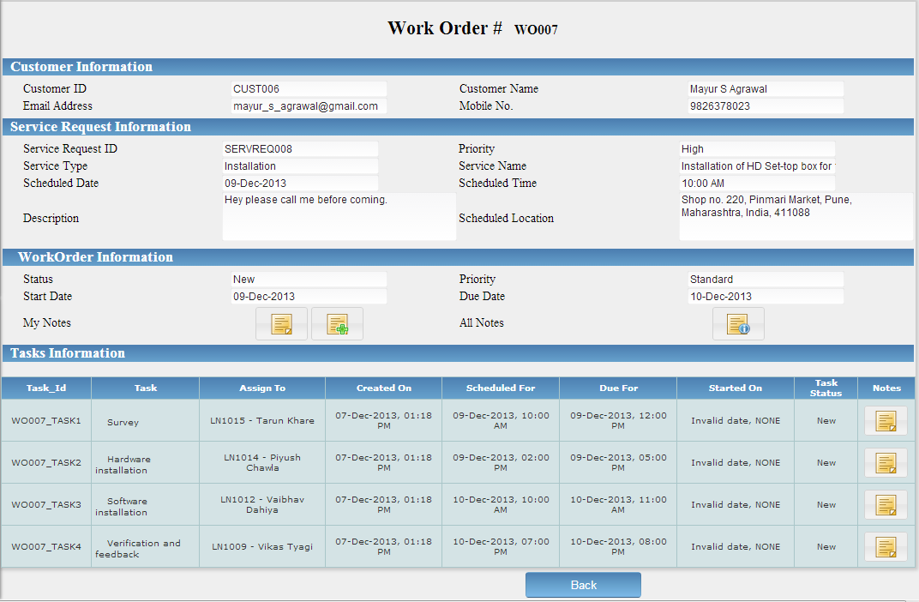

### - Task Creation

Process Description:

#### - Task allocation

Process Description:

Screen shot:

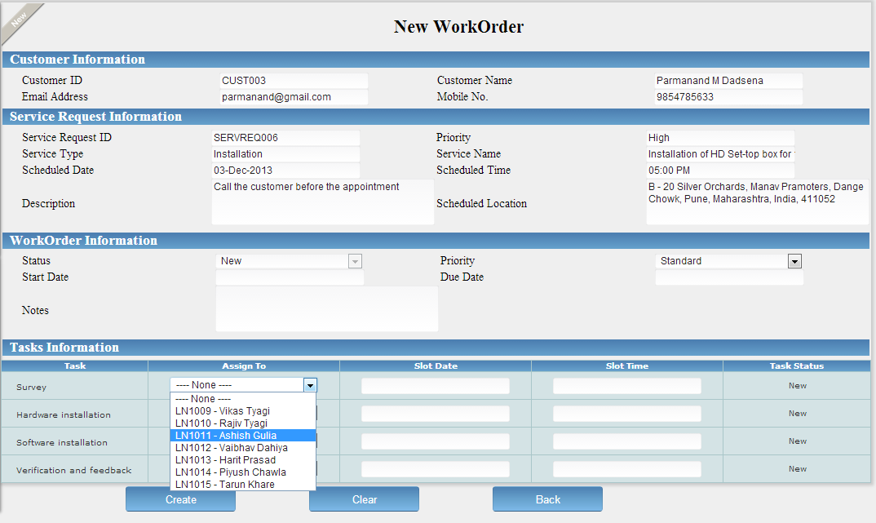

#### - Notes for Work order and Tasks

Process Description:

Screen shot:

1. Add / View Notes Options:

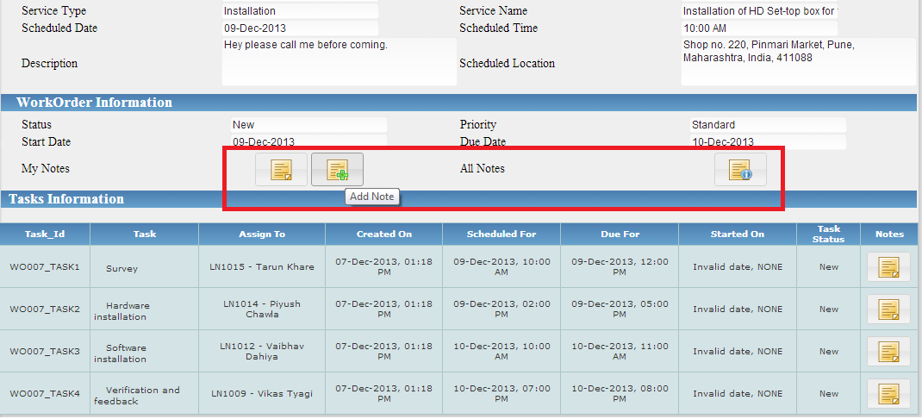

1. Add Notes:

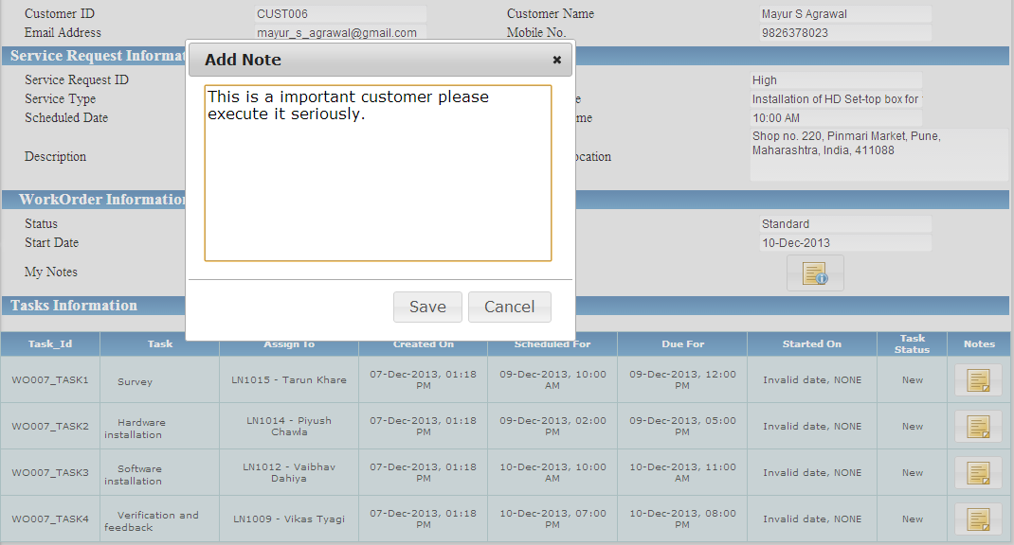

1. Add Notes:

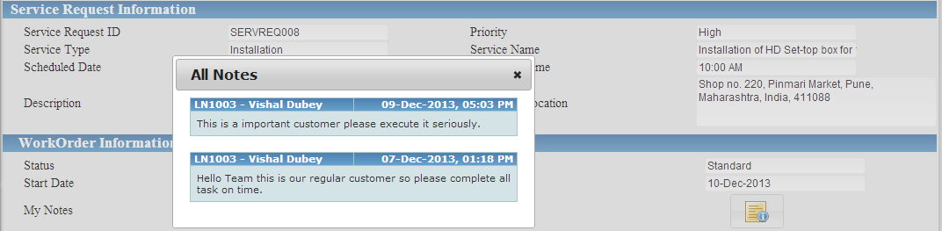

## Internal Messages

Process Description:

Screen shot:

### - Create and Send Messages

Process Description:

Screen shot:

# Mobile Application

## Work Order Task Mgmt

Process Description:

Screen shot:

### - Accept / Reject Task

Process Description:

Screen shot:

### - Task Status

Process Description:

Screen shot:

### - Capture Image and Attach to task

Process Description:

Screen shot:

### - Notes

Process Description:

Screen shot:

### - Related Customer details and History

Process Description:

Screen shot:

### - Task related Inventory

Process Description:

Screen shot:

#### = Add / Remove

Process Description:

Screen shot:

### - Estimation & Invoicing

Process Description:

Screen shot:

## Inventory Mgmt

Process Description:

Screen shot:

### - Service Engineer's allocated Inventory stock

Process Description:

Screen shot:

### - Requisition for additional Inventory

Process Description:

Screen shot:

#### - Requisition

Process Description:

Screen shot:

#### - Pending List of Requisition

Process Description:

Screen shot:

## Message Module

Process Description:

Screen shot:

### - Create Message

Process Description:

Screen shot:

#### = Inbox

Process Description:

Screen shot:

#### = Draft

Process Description:

Screen shot:

#### = Sent / Outbox

Process Description:

Screen shot: